LATITUDE 28 X Art Dubai 2024

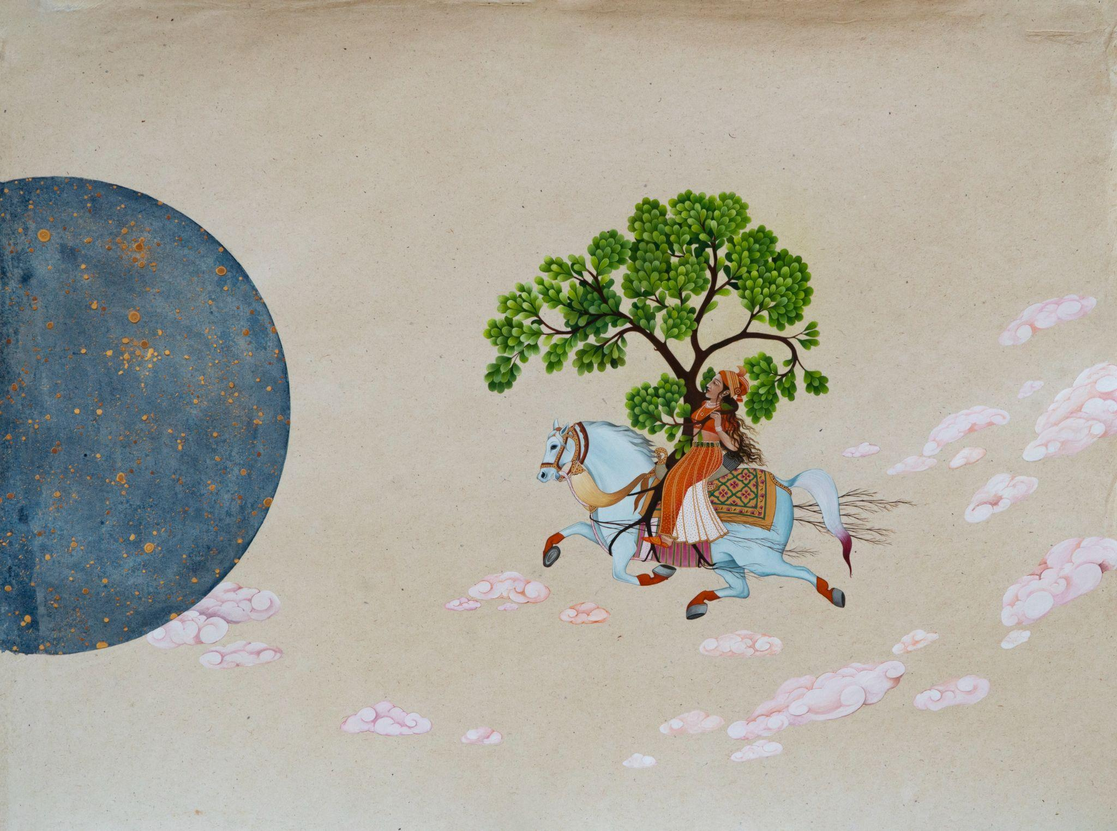
Bawwaba
Curated by Emiliano Valdés
Booth W-9

VIP PREVIEW
28th February | 2 pm - 9 pm
29th February | 2 pm - 9 pm
3rd March | 10 am - 12 pm

PUBLIC DAYS
1st March | 2 pm - 9 pm
2nd March | 2 pm - 9 pm
3rd March | 12 pm - 4 pm
Manjot Kaur, Riding on the Clouds with My Beloved, 2024, Gouache and watercolour on paper,
18.75 x 25.5 inches

This year at Art Dubai, we are excited to bring a solo presentation by Manjot Kaur as part of the Bawwaba section curated by Emiliano Valdes. Manjot is an emerging artist from South Asia whose practice explores speculative fiction, archetypal allegories, and precarious ecologies, challenging human-centred narratives. She is an active participant in prestigious residenciesand recipient of The Lakshmi Mittal and Family South Asia Institute at Harvard, Jan Van Eyck Academie in the Netherlands and Sustaina India Fellowship at CEEW (Council on Energy, Environment and Water. In our new presentation at Art Dubai, titled 'Ecosystems are Love Stories,' Manjot reimagines historical miniature paintings, addressing ecological and historical questions. The works depict scenarios like a living tree replacing a king, trees invoking a mother goddess, women embodying endangered species, heroines eloping with trees, and ecosystems producing seeds. Her art advocates for a perspective that erases hierarchical distinctions and embraces interconnectedness.

MANJOT KAUR
Ecosystems are Love Stories

Manjot Kaur’s art practice lies at the intersection of speculative fiction, archetypal allegories, and precarious ecologies that push back against the centering of the human as the protagonist while advocating for a way of thinking that eradicates the hierarchy of being. Her paintings explore what it means to be human, what it means to be non-human, and where these meanings rupture and collide. In this process, she opens up possibilities for a post-queer and post-human world where beings move towards an uncanny kind of becoming.

How can we make kin with other species? How do we undo the deep-rooted notion that humans are at the apex of all the species?

In an attempt to de-patriarch-ize the sovereignty of ecology, she cross-pollinates ancient mythologies and stories with fiction and speculation to create new visual stories in the form of miniature paintings. Inventing fiction from mythology and the natural world offers powerful tools to de-modernize the existing dualist constructs of nature and culture, raising questions on access to power and agency. Her narratives propose and encourage symbiotic cohabitation with the more-than-human species.

The current presentation of works titled ‘Ecosystems are Love Stories’ weaves new myths for contemporary times by referring to historical miniature paintings of various schools. These paintings delve deep into foundational questions concerning ecology and history. What happens when a living tree replaces a king? What happens when trees come together to invoke a mother goddess? What happens when women take over the identity of endangered species? What happens when a heroine runs away with a tree? What happens when ecosystems decide to produce seeds?

Kaur’s works are intimate worlds encompassing the anthropology of wonder and awe, proposing narratives that imagine a multi-species future. While providing new meaning to the ancient narratives, fictionalisation and a critique of history takes center-stage. This process then becomes a paradigm of change to create kinship that generates hope, love, and desperate desires for silent companionship with other species.

She believes that these new visual stories provide us with alternative routes to un-civilize from the masculine capitalist culture and carve a path to find means to cohabit and flourish in sync with nature. This model of ethical living will generate a sense of happiness that will not be based on the cost of other’s well-being and the destruction of ecology. Threaded throughout these stories are revelations of sexuality, fecundity, kinship, and freedom to rethink the meaning of motherhood in present times.

Here, storytelling reasserts the role of ‘more than mere entertainment and instead captures the essence of symbiosis and reciprocity amongst interspecies relationships. The works reflect on the intertwining of naturecultures and break the dualist construct of nature and culture as entities existing in isolation, opening up multi-layered conversations between motherhood and ecology, nature and culture, care and symbiosis, post-queer and uncanny, human and non-human relations, power and agency.

About the Artist:

Manjot Kaur’s (b. 1989, Ludhiana, Punjab, India) drawings, paintings, and Time-based media attempt to de-patriarch-ize the sovereignty of ecology and women’s bodies. She cross-pollinates ancient mythologies and histories to reflect on the relationship between humans and more than humans. Her works delve deep into intimate worlds encompassing the anthropology of wonder and awe, proposing narratives that imagine a multi-species future, by responding to ecological grief and loneliness through acts of care and kinship.
Manjot has received many prestigious grants and fellowships such as The Lakshmi Mittal and Family South Asia Institute at Harvard University, Cambridge, USA in March - April 2023; Sustaina India Fellowship at CEEW (Council on Energy, Environment and Water) and Generator Art Production Fund grant from Experimenter Gallery, India in 2022. She has been an artist in residence at Jan van Eyck Academie, Maastricht, Netherlands, 2020-21; 1 Shanthiroad, Bangalore, 2019; Unidee, Cittadellarte Fondazione Pistoletto, Italy 2018 funded by Inlaks Shivdasani Foundation, India; Peers - Khoj International Artists' Association, New Delhi, 2018 and Museo Casa Masaccio Centro per l’Arte Contemporanea, San Giovanni Valdarno, Italy – a cross-institutional program with Clark House Initiative, Mumbai, 2018.
Her recent participations include ‘Green Snake - Women Centered Ecologies’ curated by Kathryn Weir, at Tai Kwun, Hong Kong, 2023; Tomorrows/Today section at Investec Cape Town Art Fair curated by Mariella Franzoni, with Gallery Caroline O’Breen, Amsterdam; ‘Becoming Earths’, Gallery Caroline O’Breen, Amsterdam during Amsterdam Art Week, 2023; Art Mumbai with LATITUDE 28, Mumbai, 2023; Delhi Contemporary Art Week with LATITUDE 28, Bikaner House, New Delhi, 2023; ‘Conjunction of the Spheres’, curated by Girish Shahane, Delhi Contemporary Art Week, Bikaner House, New Delhi, 2023; India Art Fair with LATITUDE 28, New Delhi, 2023; ‘Where Shall We Plant The Placenta’ curated by Julia Geerlings at A Tale of A Tub, Rotterdam, 2022; ‘Non-Fungible Speculations’ curated by Srinivas Aditya Mopidevi, Nature Morte, New Delhi, 2022; ‘The World Awaits You Like a Garden’ with curatorial advice by Sugata Ray, LATITUDE 28, New Delhi, 2022; ‘The Pool of Memories’ curated by Suvi Bains, Surrey Art Gallery, Canada, 2022; ‘Hurting and Healing - Let's Imagine a Different Heritage’ curated by Charles Ecshe, Tensta Konsthall, Stockholm, 2022; ‘Terrain Offline’, Bikaner House, New Delhi, India, 2021 and ‘Garden State’ curated by Fadwa Naamna, Garage Rotterdam, Rotterdam, Netherlands, 2021 among others.
Her awards include State Award, Punjab Lalit Kala Akademi, Chandigarh, 2018; Sohan Qadri Fellowship, Chandigarh Lalit Kala Akademi, Chandigarh, 2017; State Award, Chandigarh Lalit Kala Akademi, Chandigarh, 2017 and 2012, and Scholarship to Young Artists, Chandigarh Lalit Kala Akademi, 2011. She was chosen by Hindustan Times as one of the Top 30-under-30 young achievers in 2017. Manjot Kaur is represented by LATITUDE 28.

ABOUT THE GALLERY

Since 2010, LATITUDE 28 has probed into new gallery practice, one that is lateral, disruptive and avant-garde. Discerning emerging artists making their mark in the Indian Subcontinent including Pakistan, Nepal and Sri Lanka and beyond such as Iran, LATITUDE 28’s artists respond to the critical conversations of our times or the annals of their surreal imaginations. LATITUDE 28 has stimulated artists, writers, critics, researchers and curators to experiment with medium, material, dialogue, perspective and practice while fostering collectors, art enthusiasts and takers of a new era. These maker-market relationships have grown through the gallery’s interactive incubation space, where ideas have been generated through curatorial projects within art history and socio-political contexts, site-specific artworks and artist talks. The gallery makes art accessible and inclusive with exhibitions located at the intersection of artists, art institutions, collectors and many different publics. With its critical writing on contemporary art through TAKE on Art Magazine, it has supported cutting-edge content, critical writing ensembles, workshops and awards for new writers. LATITUDE 28’s vision is shaped by its Founder/Director, Bhavna Kakar, who is also the founder and editor of TAKE on Art - South Asia’s leading contemporary art publication.

SOCIAL MEDIA HANDLES
Facebook: https://www.facebook.com/GalleryLatitude28
Instagram: @latitude_28 @bhavz15 @takeonart

